Question 1 (2 points)

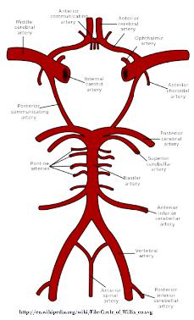
The cerebral arterial circle (Circle of Willis) is a vascular structure that allows confluence between the blood arriving from the left and right sides of the body through several arteries. After you have explored the anatomy of this structure, answer the following questions.
How does the organization of this structure help to perform its function(s)?
In light of this function, what is the main potential advantage for the brain for such an organization?
The Circle is thought to be complete in only about 20% of individuals. Why might even an incomplete circle be better than no connection between sides at all in performing its main function?
Finally, undertakers find that the Circle of Willis complicates their task of embalming the body of a deceased person. How might this structure affect the ability to infuse the brain with embalming fluid, replacing all the blood in the vessels of the brain?
Hint: Think of a revolving door or a traffic circle.

Question 1 write answer here

Question 2 (3 points)

For the following description, identify FOUR(4) structures and pathways in the nervous system that are responsible for the experiences reported.
Beginning with the arrival of the receptor potential, identify the areas of the brain that would be involved in the neurological response to the stimulus. What parts of the brain does the signal activate, how does it get there, what happens there as a result of the signal, and what is the output?
Specify whether each pathway is somesthetic or autonomic; and whether the response is reflexive or intentional (voluntary), cognitive or subconscious.
The minute she walked into the room she sensed it. Even as she reached for the light switch, she felt the hair standing up on the back of her neck and a shudder running down her spine. She felt a thin layer of moisture cover her body. There was a strange nagging, deep down—some long-buried memory—and whatever it was was here now. As she bent down to pick up her mail, it clicked. Bay Rum! Good Lord, did men still splash themselves with heavy, sweet alcoholic scents? In this day and age?
Then the memories flooded over her. She imagined being pulled violently and catapulted into the air until she thought her head would explode; she was spun wildly in circles until the whole universe was a blur. She remembered being alternately pushed and shoved till she swung in large arcs that left her queasy and nauseated. It had been so long. Where were these memories coming from?
She snapped on the lights and look quickly around her tiny apartment. No one! She lifted her hands to take off her scarf, the letters still in her hand. Then it hit her — cigars! She held the letters at arm's length, postmark "Naples, Florida".
"Grandpa!" she cried, and flopped down on the couch with a giggle to read the old man's latest letter.

Question write answer here :

Question 3 (3 points)

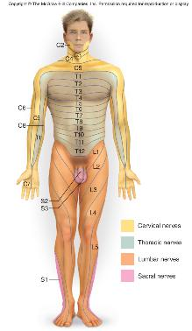
Diabetics typically suffer from neuropathies: damage to the nerves that causes pain, tingling, and eventual loss of function. Neuropathies in the lower limbs can be due to local damage to peripheral nerves in the feet and ankles, or to damage that occurs in the lumbar plexus.
Looking at the diagram and the anatomic relations of the nerves in the lower limbs, describe what differences that you should be able to observe in order to differentiate between peripheral and lumbar plexus neuropathies for an individual complaining of pain or tingling in the feet and ankles.
In what way should the experience of the neuropathy differ between these two causes?

Question 3 write answer here

Question 4 (2 points)

Long before our human ancestors showed the anatomical specializations associated with speech, they had developed advanced dexterity of the hands, as evidenced by the production of complex tools and artifacts. It is likely, therefore, that they developed a rich “vocabulary” of gestures to aid in communication. One modern communicative hand gesture in North America is the “digital salute" (aka, “the bird”).
A careful observation of the anatomical relations involved in “flipping the bird” is that the person performing this action often will hold digits 2, 4, and 5 in flexion by adducting and flexing digit 1 in order to sustain the unique extension of digit 3.
Examine the neuromuscular interactions that are responsible for this situation. How do the nerves, muscles, bones, and joints interact in making this hand sign in a way that is different from the unmodified (or unpracticed) movements of these structures in the hand? What has to be modified for a successful digital salute?
Be sure to identify the muscles that contribute to these actions and the nerves that supply them, and to describe how the interactions of the nerves with the muscles, bones, and joints accomplish this phenomenon.
Anatomically speaking, explain why this movement is difficult to do unless one specifically learns the correct actions (what nerves supply the "normal/natural" actions of these muscles and how their activation must be changed to produce these movements of the bones and joints)
In addition, identify where the "motor program" needs to be modified ... at the level of the hand muscles, in the spinal cord, or in the brain (and where in the brain)..so that this movement can be done smoothly with practice.
HINT: remember that this assignment is in the unit on the brain and nervous system, so your answers should be focused accordingly.

